AIM

To demonstrate virtualization by installing a Type-2 Hypervisor (VMware Workstation) on a physical device and creating/configuring a Virtual Machine (VM) with a host operating system (Windows/Linux).

PROCEDURE

1. Install VMware Workstation: Download VMware Workstation Pro or VMware Workstation Player from the official website: https://www.vmware.com.
  - Install it on your physical device (Windows/Linux host system).

2. Download Guest OS ISO File: Choose the OS to install (e.g., Ubuntu Linux ISO or Windows 10 ISO).
  - Keep the ISO image ready.

3.Create a New Virtual Machine: Open VMware Workstation → Click Create a New Virtual Machine.
  - Choose Typical (recommended) setup.
  - Select Installer disc image file (ISO) and browse for your OS ISO.

4.Set Guest Operating System Type: Select Microsoft Windows or Linux as per your ISO.
  - Select the OS version (e.g., Windows 10 x64 / Ubuntu 64-bit).

5.Configure VM Hardware Resources: Assign RAM (2GB+ for Linux, 4GB+ for Windows).
  - Assign Processors (1–2 cores).
  - Create a Virtual Hard Disk (20GB+).

6.Customize VM Settings (Optional): Enable Network Adapter (choose NAT or Bridged).
  - Configure Display and Shared Folders if needed.

7.Install the Guest Operating System: Power on the VM.

  - Follow the OS installation steps (language, partitions, user creation).

  - 8.Post Installation Setup: Install VMware Tools for better graphics, drag-and-drop, clipboard sharing.
  - Verify that networking, file sharing, and system performance work correctly.

  - OUTPUT

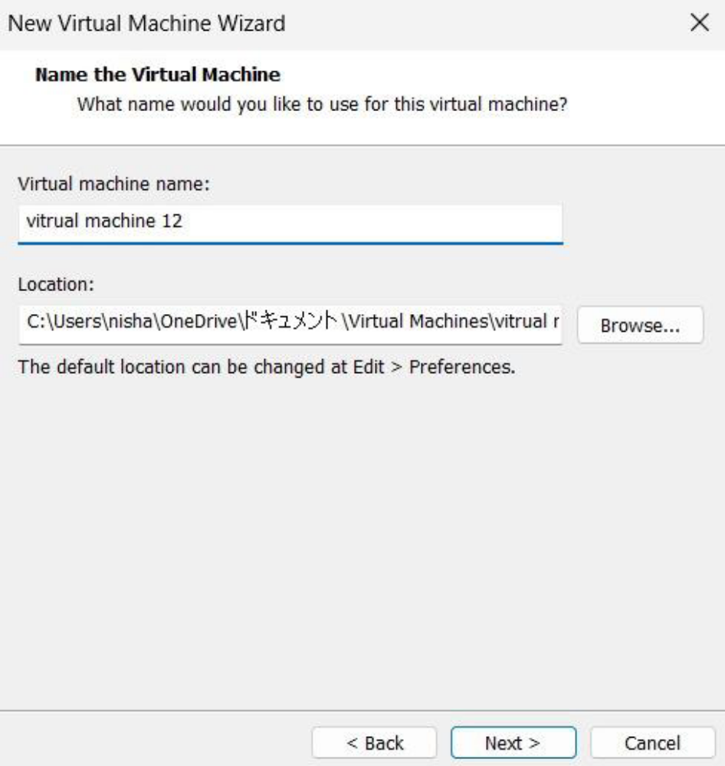
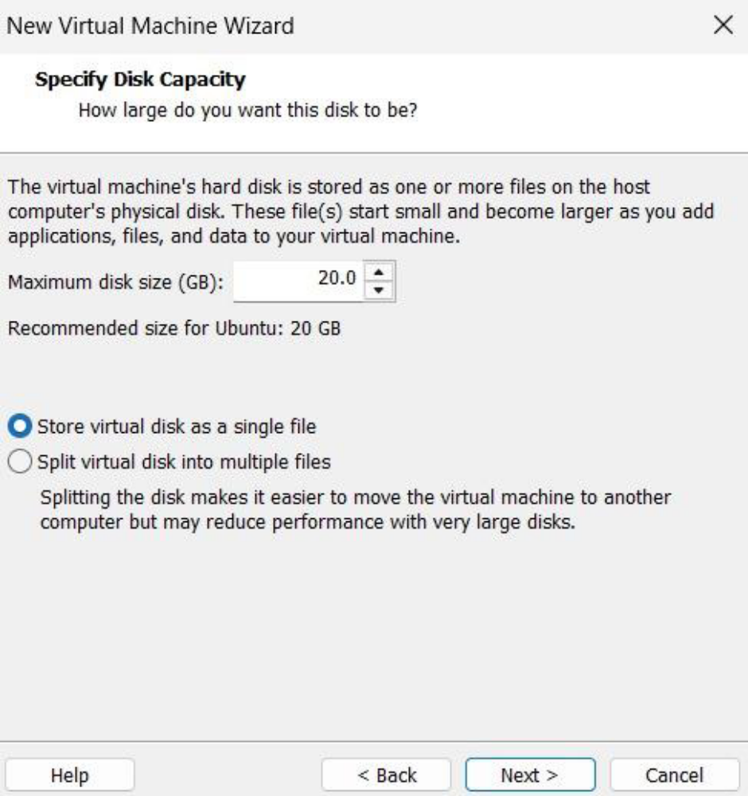
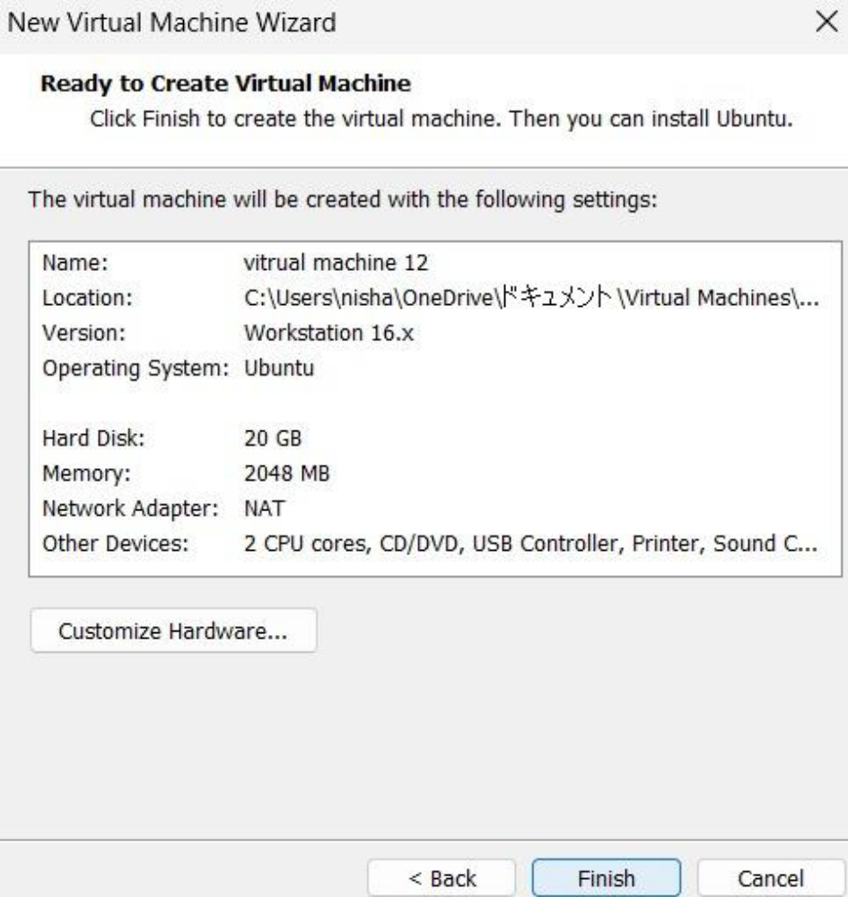
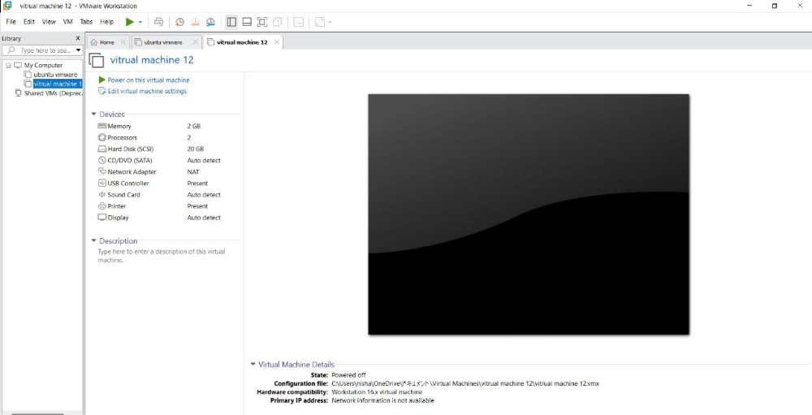
RESULT
Virtualization was successfully demonstrated by using VMware Workstation (Type-2 Hypervisor). A Virtual Machine was created, configured, and installed with a host operating system (Windows/Linux), showing the ability to run multiple operating systems on a single physical device.

